EXPT NO: 4 | TRANSFER LEARNING USING PRE-TRAINED VISION MODELS FOR IMAGE RECOGNITION
DATE: 04-09-2026

PRE-LAB QUESTIONS (PROVIDE BRIEF ANSWERS TO THE FOLLOWING QUESTIONS)
- What is transfer learning in deep learning?

Transfer learning is a technique where a model trained on a large dataset is reused for a new but related task. The pre-trained model provides useful features that can be adapted to the new dataset.

- What are the advantages of using pre-trained models over training from scratch?

Pre-trained models require less training time, less data, and fewer computational resources. They can also provide higher accuracy because they have already learned useful features from large datasets.

- What is the role of fine-tuning in transfer learning?

Fine-tuning involves training some or all layers of a pre-trained model on the new dataset with a small learning rate. It allows the model to adapt its learned features to the specific task.

- Name any three popular pre-trained computer vision models.

Three popular pre-trained computer vision models are:
- ResNet-50
- VGG16
- MobileNet

- What is the purpose of Hugging Face and how is it useful in deep learning?

Hugging Face is a platform that provides pre-trained models, datasets, and tools for machine learning. It makes it easy to download, use, fine-tune, and deploy models for tasks such as image classification, text processing, and object detection.
AIM
To implement transfer learning using pre-trained vision models for image recognition and evaluate their performance on real-world image datasets.

SOFTWARE REQUIREMENTS
- Python
- TensorFlow/Keras or PyTorch
- Google Colab
- Hugging Face Transformers
- Kaggle Dataset
- Matplotlib
- GitHub

OBJECTIVES
Students will be able to:
- Understand the concept of transfer learning.
- Apply pre-trained vision models for image recognition.
- Fine-tune models such as ResNet or AlexNet.
- Utilize Kaggle datasets and Hugging Face vision models.
- Compare transfer learning performance with custom CNN models.

Task A: DATASET PREPARATION
Perform the following tasks:
- Download an image dataset from Kaggle.
- Load and preprocess the images.
- Split the dataset into training, validation, and testing sets.

Task B: IMPLEMENTING TRANSFER LEARNING
Load a pre-trained model such as:
- ResNet-50
- AlexNet
Replace the final classification layer according to the dataset classes.
Freeze the feature extraction layers.
Compile the model.

Task C: MODEL TRAINING AND PERFORMANCE EVALUATION
Train the transfer learning model.
Record:
- Training accuracy
- Validation accuracy
- Training loss
- Validation loss
- Test accuracy
Visualize:
- Accuracy vs Epoch
- Loss vs Epoch

Task D: USING HUGGING FACE PRE-TRAINED MODELS
Perform the following tasks:
- Load a pre-trained vision model from Hugging Face.
- Perform image classification on sample images.
- Compare predictions with the transfer learning model.
- Document observations and upload the notebook to GitHub.

SCREENSHOT OF CODE & OUTPUT

TASK A:

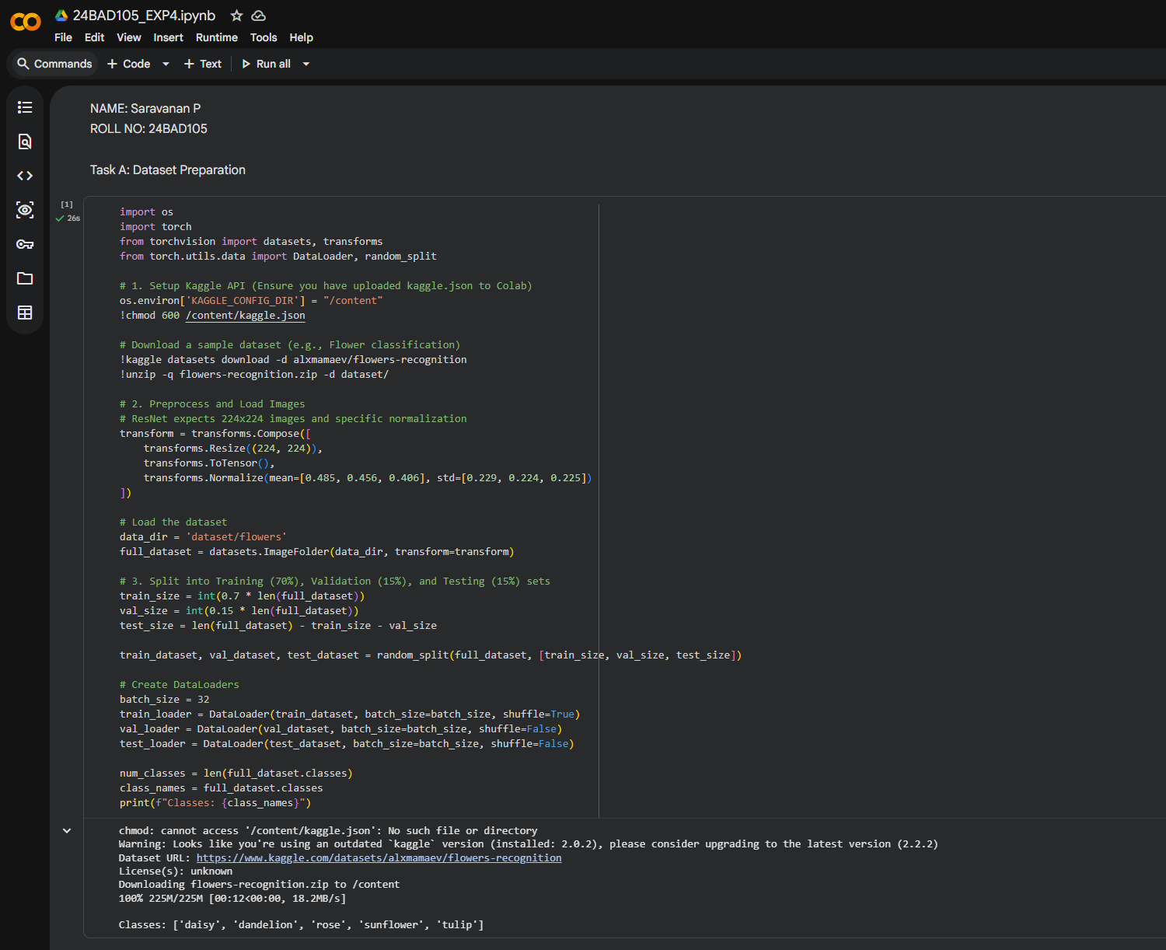

TASK B:

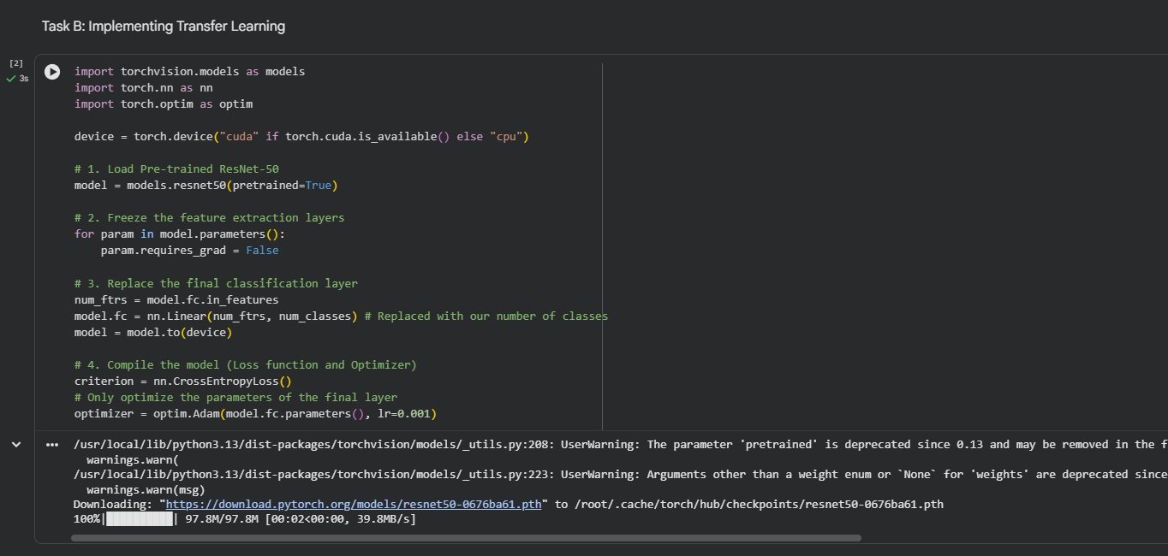

TASK C:

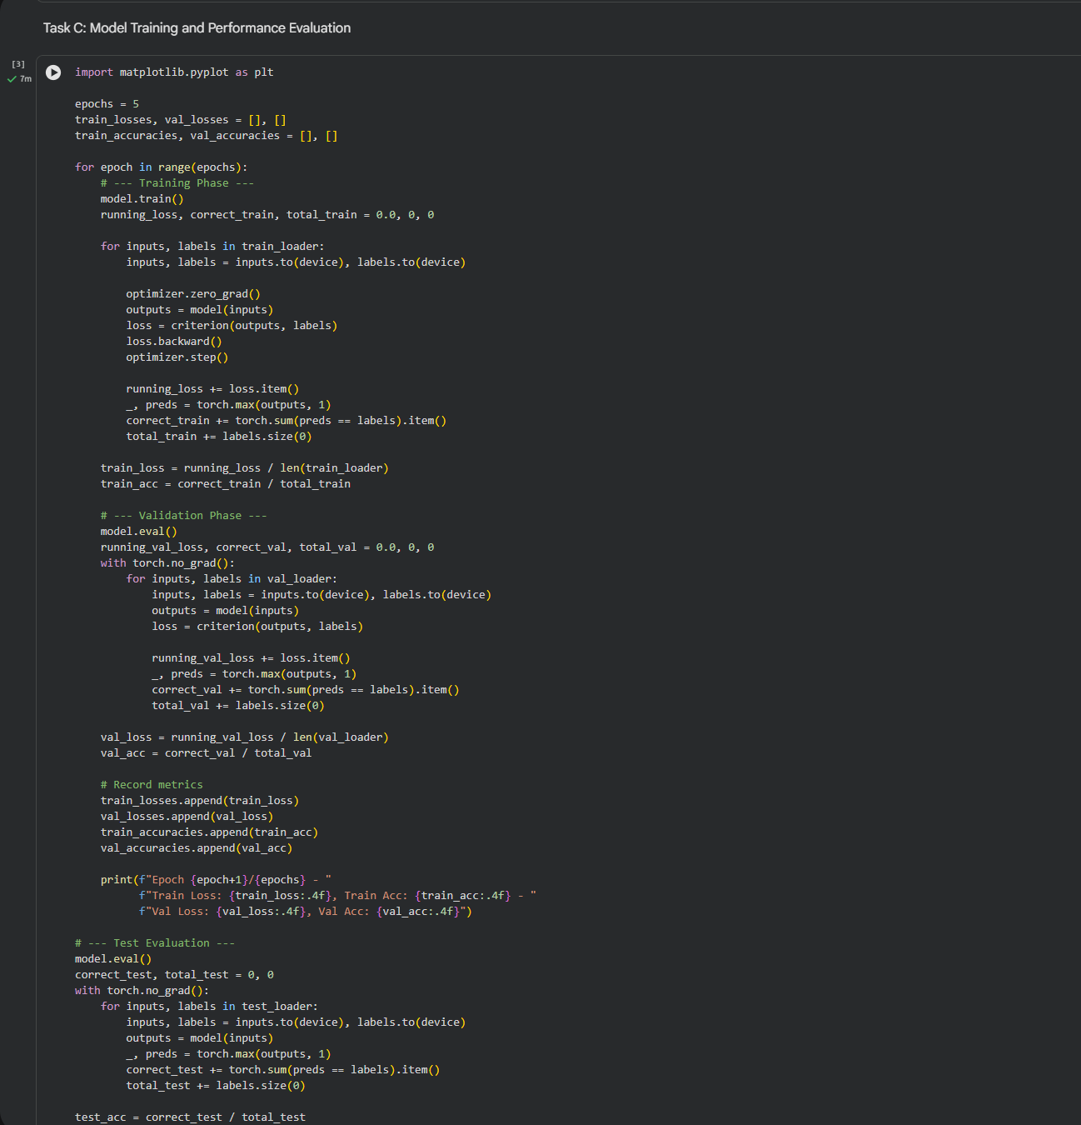

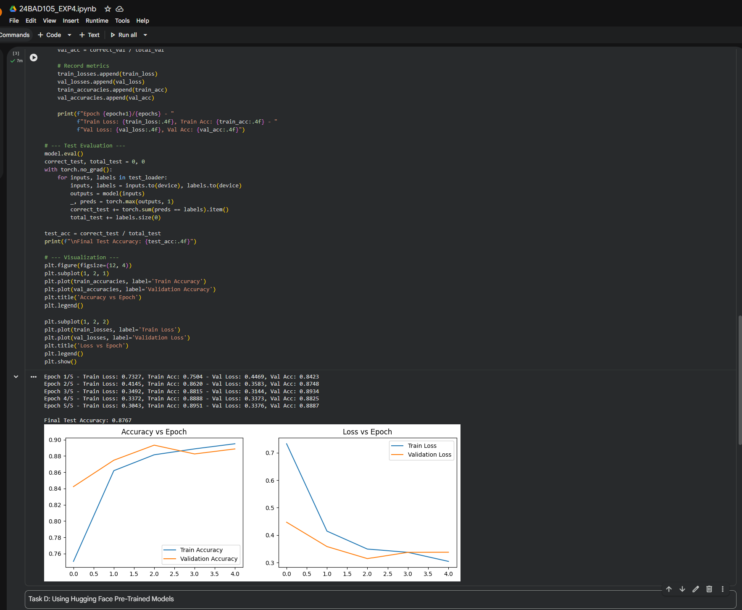
TASK D:

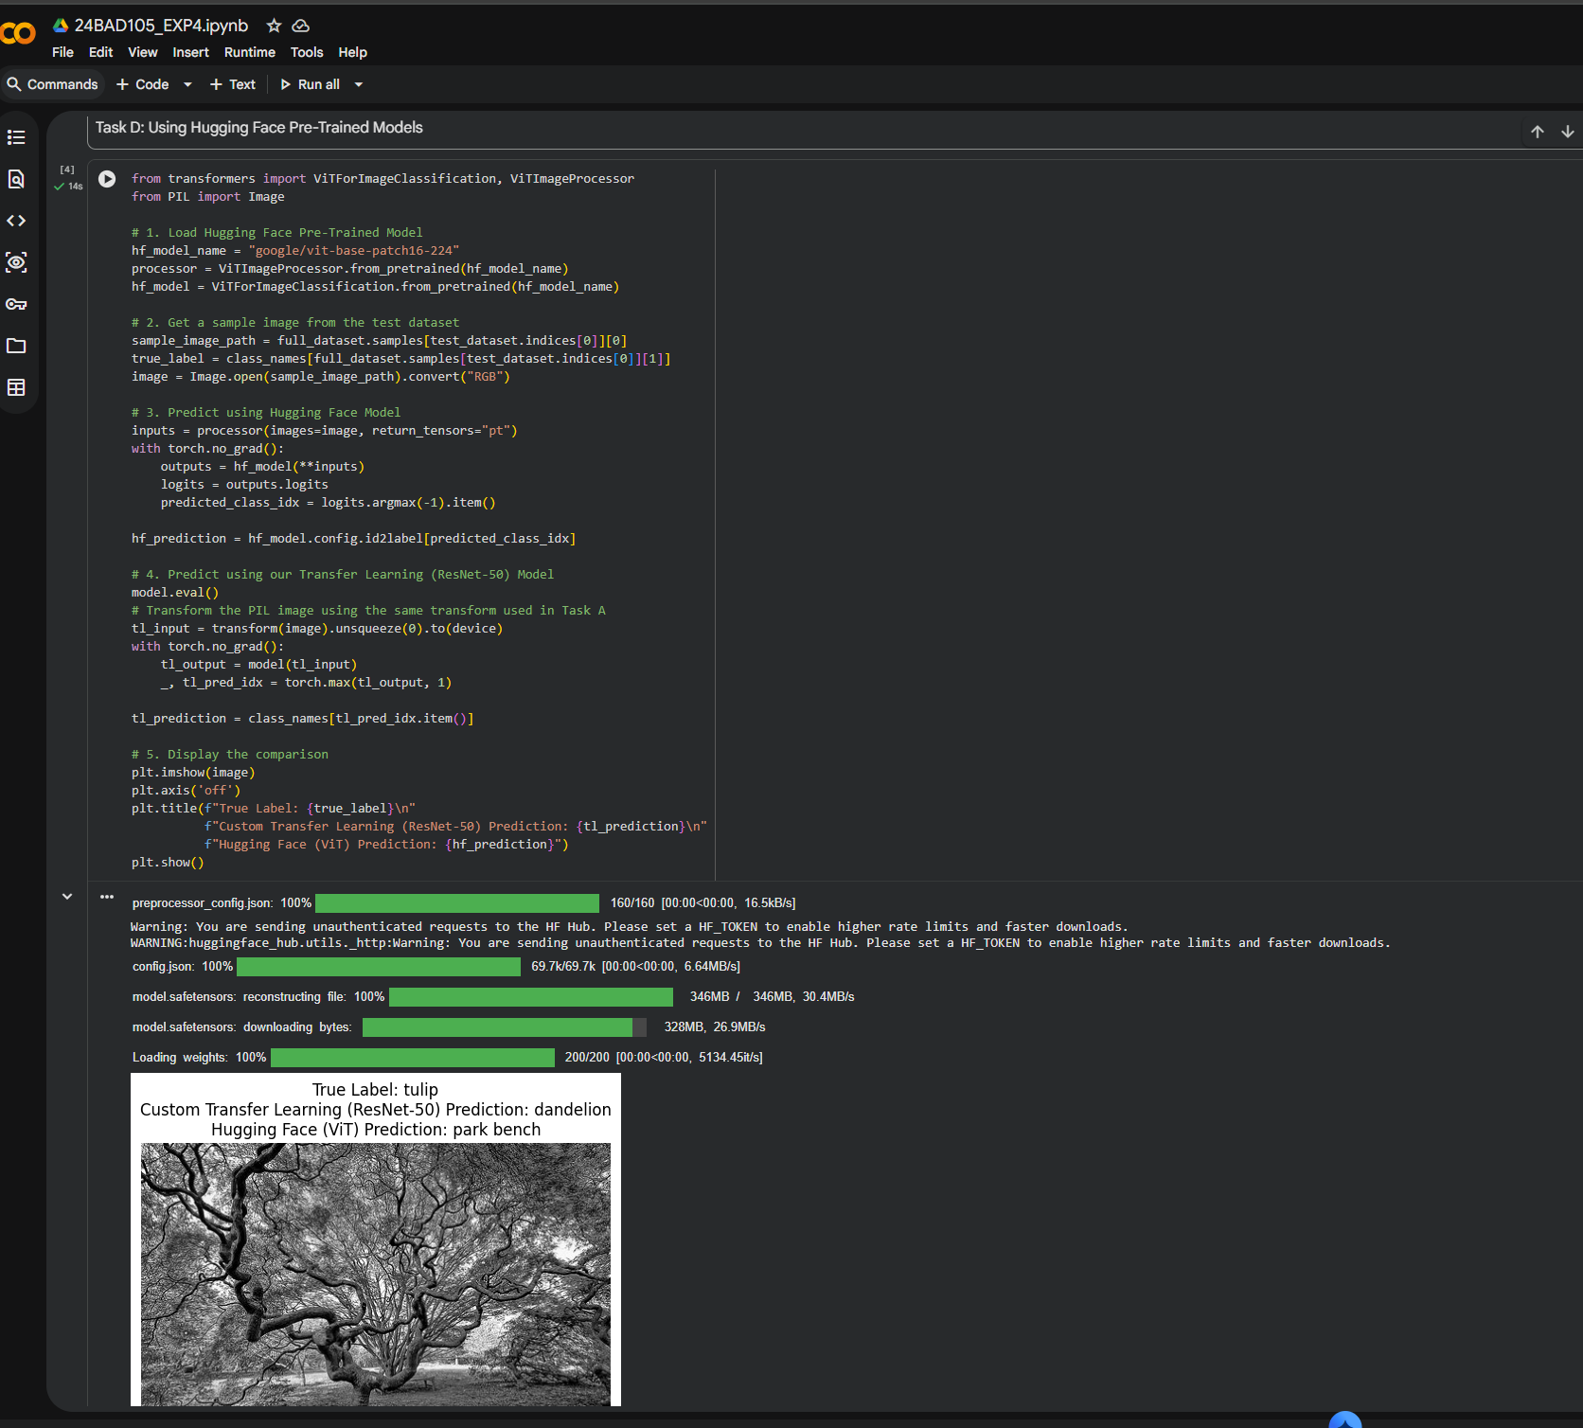

POST-LAB QUESTIONS (PROVIDE BRIEF ANSWERS TO THE FOLLOWING QUESTIONS)
- What are the advantages of transfer learning compared to training a CNN from scratch?

Transfer learning requires less training data and computational time. It also converges faster and often achieves better accuracy because the model already contains useful features learned from a large dataset.

- Why are pre-trained models able to achieve higher accuracy with fewer training epochs?

Pre-trained models have already learned important features such as edges, shapes, textures, and patterns from large datasets. Therefore, they need fewer epochs to adapt these features to the new classification task.

- Compare the performance of the transfer learning model with the CNN implemented in the previous experiment.

The transfer learning model generally provides higher validation and test accuracy with faster convergence than the custom CNN. This is because the pre-trained model starts with useful learned features instead of learning everything from the beginning.

- What is the purpose of freezing layers during transfer learning?

Freezing layers prevents their weights from being updated during training. This preserves the general features learned from the original dataset and reduces training time and computational requirements.
- How can Hugging Face simplify the deployment and experimentation of vision models?

Hugging Face provides ready-to-use pre-trained models, processors, datasets, and APIs. Users can easily load and test vision models without implementing the complete architecture from scratch, making experimentation and deployment faster and easier.

ASSESSMENT
Description | Max Marks | Marks Awarded
Pre Lab Exercise | 5
In Lab Exercise | 10
Post Lab Exercise | 5
Viva | 10
Total | 30
Faculty Signature

